AI ASSISTED CODING
Name:P.BHARATH
Ht.No: 2303A52237
Batch:36
Assignment-1.5
Task-0:
❖ Install and configure GitHub Copilot in VS Code. Take screenshots of each step.
Expected Output:
❖ Install and configure GitHub Copilot in VS Code. Take screenshots of each step.
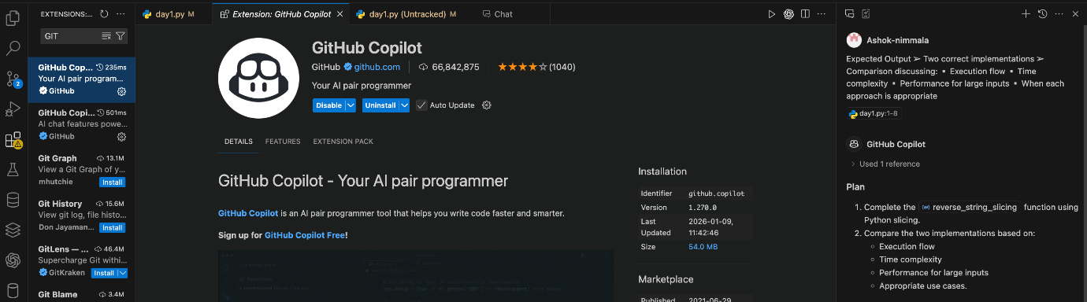
Task-1:
AI-Generated Logic Without Modularization (String Reversal Without
Functions))
Scenario:
You are developing a basic text-processing utility for a messaging
Application
Task Description
Use GitHub Copilot to generate a Python program that:
➢ Reverses a given string
➢ Accepts user input
➢ Implements the logic directly in the main code
➢ Does not use any user-defined functions
Expected Output
➢ Correct reversed string
➢ Screenshots showing Copilot-generated code suggestions
➢ Sample inputs and outputs
Code
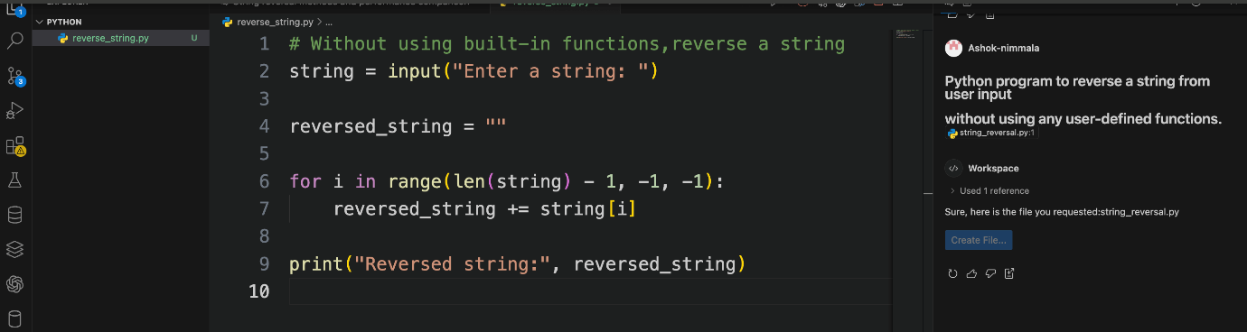
Output:


Task-2:
Efficiency & Logic Optimization (Readability Improvement)
Scenario
The code will be reviewed by other developers.
Task Description
Examine the Copilot-generated code from Task 1 and improve it by:
➢ Removing unnecessary variables
➢ Simplifying loop or indexing logic
➢ Improving readability
➢ Use Copilot prompts like:
▪ “Simplify this string reversal code”
▪ “Improve readability and efficiency”
Hint:
Prompt Copilot with phrases like
“optimize this code”, “simplify logic”, or “make it more readable”
Expected Output
➢ Original and optimized code versions
➢ Explanation of how the improvements reduce time complexity
Code & Output:
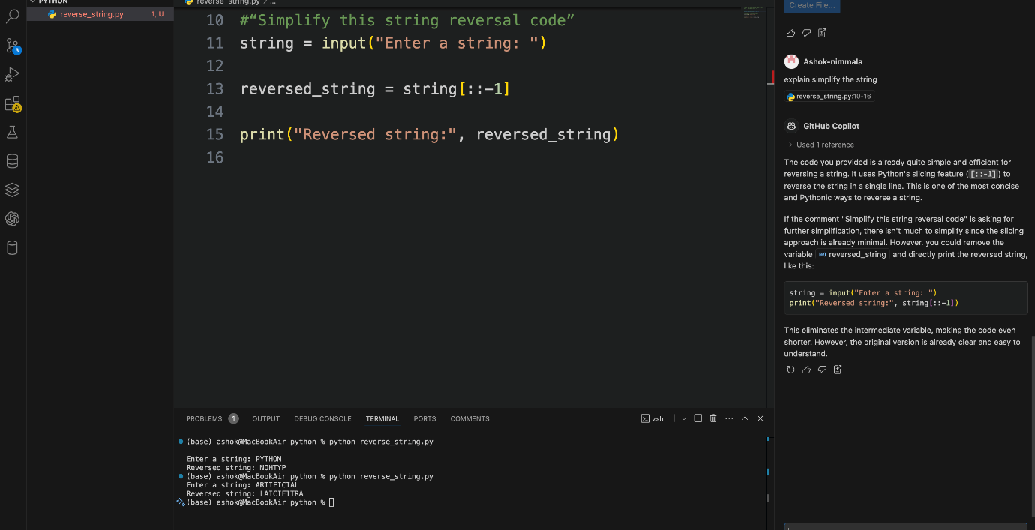

Justification:
By prompting Copilot with
“optimize this code”, “simplify logic”, and “make it more readable”,
the code was reduced from a loop-based O(n²) approach to an efficient O(n) solution using slicing
Task-3:
Modular Design Using AI Assistance (String Reversal Using Functions)
Scenario
The string reversal logic is needed in multiple parts of an application.
Task Description
Use GitHub Copilot to generate a function-based Python program that:
➢ Uses a user-defined function to reverse a string
➢ Returns the reversed string
➢ Includes meaningful comments (AI-assisted)
Expected Output
➢ Correct function-based implementation
➢ Screenshots documenting Copilot’s function generation
➢ Sample test cases and outputs
Output:
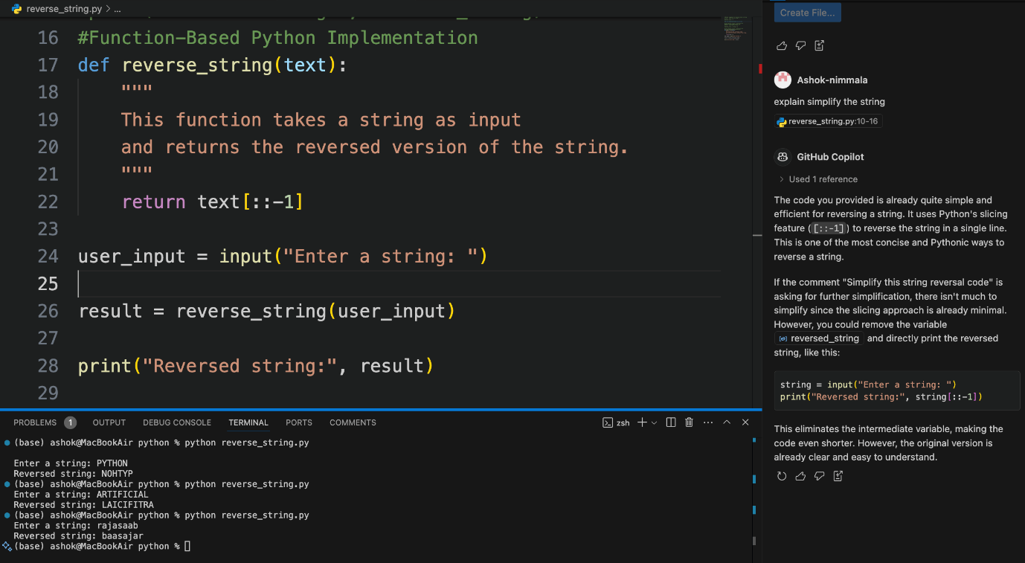

Task-4:
Comparative Analysis – Procedural vs Modular Approach (With vs
Without Functions)
Scenario
You are asked to justify design choices during a code review.
Task Description
Compare the Copilot-generated programs:
➢ Without functions (Task 1)
➢ With functions (Task 3)
Analyze them based on:
➢ Code clarity
➢ Reusability
➢ Debugging ease
➢ Suitability for large-scale applications
Expected Output
Comparison table or short analytical report
Report:
In the procedural approach (Task 1), the string reversal logic is implemented directly in the main code. While this method is simple and suitable for very small programs, it leads to poor reusability and reduced readability when the same logic is required multiple times. Debugging also becomes challenging as the application grows.
In contrast, the modular approach (Task 3) uses a user-defined function to encapsulate the string reversal logic. This significantly improves code clarity, maintainability, and scalability. The function-based design allows the logic to be reused across multiple modules, making it ideal for large-scale and real-world applications. Additionally, modular code aligns with best software engineering practices and simplifies debugging and testing.
Conclusion:
During a code review, the modular (function-based) approach should be preferred over the procedural approach because it:
Enhances readability
Promotes reusability
Simplifies debugging
Supports scalable application design

Task-5:
AI-Generated Iterative vs Recursive Fibonacci Approaches (Different
Algorithmic Approaches to String Reversal)
Scenario
Your mentor wants to evaluate how AI handles alternative logic paths.
Task Description
Prompt GitHub Copilot to generate:
➢ A loop-based string reversal approach
➢ A built-in / slicing-based string reversal approach
Expected Output
➢ Two correct implementations
➢ Comparison discussing:
▪ Execution flow
▪ Time complexity
▪ Performance for large inputs
▪ When each approach is appropriate

Code:
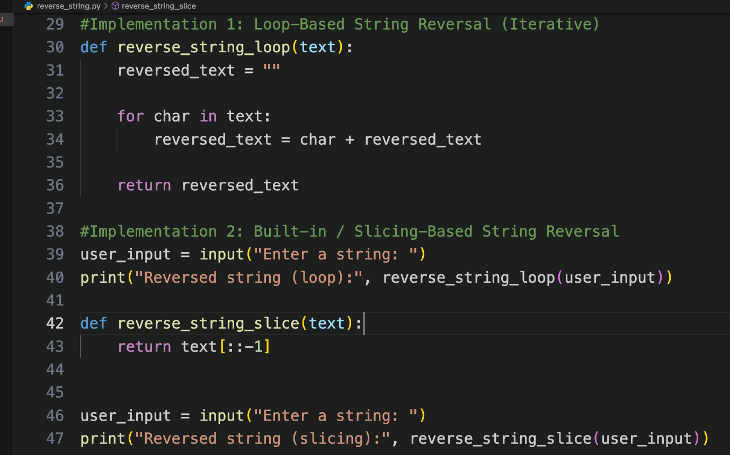

Comparison:
Execution Flow
Loop-Based: Reverses the string character by character using a loop.
Slicing-Based: Uses Python’s built-in slicing to reverse the string in one step.
Time Complexity
Loop-Based: O(n²) due to repeated string concatenation.
Slicing-Based: O(n) because it processes the string in a single pass.
Performance for Large Inputs
Loop-Based: Slower and inefficient for large strings.
Slicing-Based: Fast and efficient even for large inputs.
When Each Approach is Appropriate
Loop-Based: Suitable for learning basic logic and algorithm understanding.
Slicing-Based: Best for real-world applications and production code.

Conclusion:
Both approaches work correctly, but the slicing-based method is preferred due to better performance, simplicity, and scalability.

